Section 1 Notes
What influenced the dispersal of golf over time to other places?
The dispersal of golf from Scotland to the British Isles, then to the rest of the British Empire is shown below. https://general-history.com/the-british-empire-in-1920/
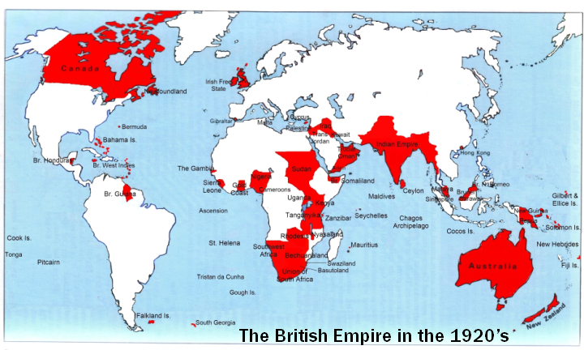

The 1920’s can be said to be where golf really took off, as the US is the biggest ambassador of the sport to this day. Tournament golf had become a well-established spectator sport in the United States by the 1920s and has been gaining popularity ever since. Professional Golfers' Association of America (PGA of America), organization formed in the United States in 1916 at the instigation of Rodman Wanamaker, a Philadelphia businessman, with the stated purpose of promoting interest in professional golf, elevating the standards of the game, and advancing the welfare of its members.

By 1880, golf had spread to Ireland, many other parts of Europe, Australia, New Zealand, Canada, Singapore, and South Africa. Like most other countries of the world that adopted the sport early, the sport did not gain popularity in the United States until the early nineteenth century.

In the history of golf, Scottish troops, emigrants, and expatriates had a significant impact. During the 18th century, they were in charge of expanding the game throughout the British Isles which was where it was then spread around the British Empire.

The United States Golf Association was founded in 1894 to serve as ambassadors for the game in the United States, which included 267 golf clubs by 1910. Golf is known around the globe and has gained popularity, as it is becoming more televised and marketed.

The Scottish sport known as Golf had one distinguishing feature that set it apart from other sports at the time known as the hole. Golf history can be traced back to the 15th century Scotland when we're talking about the current game with 18 holes.

